CSCI 5601 – Milestone 2
(due Due: Sunday, November 20 at 11:00pm)

Group Information
Date:

Group Name:

Names

Study Summary and Data Analysis (~2 pages)
Study Purpose and Objectives: What was the purpose and objectives of your first study (~.5 page)

Data Analysis (~1.5 pages) (use the following sub-headings to describe the affinity process)
Analysis Process:

Data Analysis/Results:

Suggested Features:

Features to Prototype:

Data Modeling and Prototype (~1.5-2 pages)
User Tasks (based on decided features from the Data Analysis)

Prototype Process and Description

Cognitive Walkthrough Description (~.5 page)

Appendices
Appendix A – Persona (provided)
Appendix B -- Tasks, Scenarios, Use Cases and Prototype for each feature
Appendix C – Cognitive Walkthrough Sheets
Appendix D – Work Breakdown

Note: each Appendix should start on a new page.

Appendix A – Persona

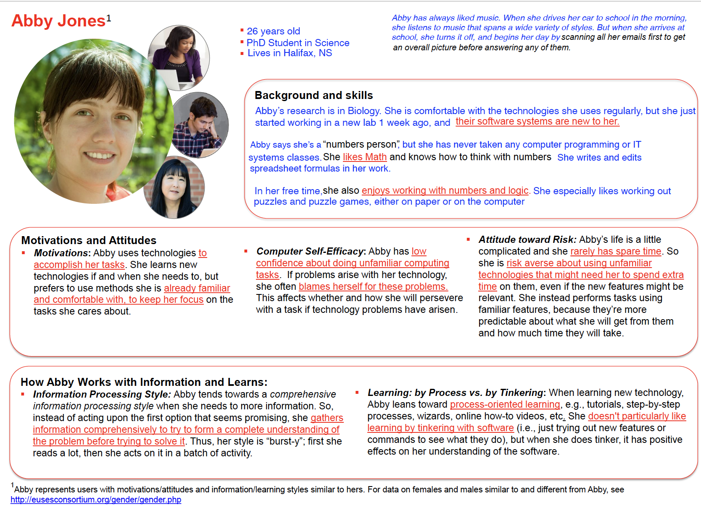
Appendix B – Task, Scenario, Use-cases and Prototype images

Three features
Feature | Description of the feature

Feature1:

Task Name:

Task Scenario:

Use-Case
Normal Case

Alternative Case

Prototype Images (you may have more or fewer images than rows – add and delete as necessary)
Image 1: Steps __________

Image 2: Steps __________

Image 3: Steps __________

Image 4: Steps __________

Image 5: Steps __________

Image 6: Steps __________

Image 7: Steps __________

Image 8: Steps __________

Image 9: Steps __________

Feature2:

Task Name:

Task Scenario:

Use-Case
Normal Case

Alternative Case

Prototype Images (you may have more or fewer images than rows – add and delete as necessary)
Image 1: Steps __________

Image 2: Steps __________

Image 3: Steps __________

Image 4: Steps __________

Image 5: Steps __________

Image 6: Steps __________

Image 7: Steps __________

Image 8: Steps __________

Image 9: Steps __________

Feature3:

Task Name:

Task Scenario:

Use-Case
Normal Case

Alternative Case

Prototype Images (you may have more or fewer images than rows – add and delete as necessary)
Image 1: Steps __________

Image 2: Steps __________

Image 3: Steps __________

Image 4: Steps __________

Image 5: Steps __________

Image 6: Steps __________

Image 7: Steps __________

Image 8: Steps __________

Image 9: Steps __________

Appendix C - Cognitive Walkthrough Sheets

Date of Evaluation: _____________________

Names of Evaluators: _________________________________________________________________________

Instructions:
In pairs, the evaluators will be walkthrough the system for each task. For each step of the use-case the evaluators will answer three questions – if Abby will know what action to take, how to do the action, and then if Abby can tell if the actions taken is correct (yes, no or maybe with a short reasons). Give any problems (a "No" or "Maybe" a severity rating from 1 to 5 (where 1 is minor and 5 is critical).

Description of System:
[main goals and objectives of the system, what type of system, e.g., mobile, web, etc]

Typical Users: Abby [include the persona that you created]

Typical Tasks: [List the main uses and tasks of the system]

Cognitive Walkthrough Sheet [Evaluation Sheet/s – Task 1]

Task Title:
Task Scenario:

[Short description of the scenario]

Step 1: [add]
Question | Yes (reason/s) | No (reason/s) | Maybe (reason/s) | Severity Rating (1-5)
Will the correct action be sufficiently evident to Abby? (“Know what to do?” -Will the Abby know what to do to achieve the task?)
Will the Abby notice that the correct action is available? (“See how to do it” - Can users see the button or menu item that they should use for the next action? Is it apparent when needed?)
Will the Abby associate and interpret the response from the action correctly (“Understand correct action/not correction” - will users know from the feedback that they have made a correct or incorrect choice of action?)
ADD the prototype image/s that matches these steps/s

Step 2: [add]
Question | Yes (reason/s) | No (reason/s) | Maybe (reason/s) | Severity Rating (1-5)
Will the correct action be sufficiently evident to Abby? (“Know what to do?” -Will the Abby know what to do to achieve the task?)
Will the Abby notice that the correct action is available? (“See how to do it” - Can users see the button or menu item that they should use for the next action? Is it apparent when needed?)
Will the Abby associate and interpret the response from the action correctly (“Understand correct action/not correction” - will users know from the feedback that they have made a correct or incorrect choice of action?)
ADD the prototype image/s that matches these steps/s

Step 3: [add]
Question | Yes (reason/s) | No (reason/s) | Maybe (reason/s) | Severity Rating (1-5)
Will the correct action be sufficiently evident to Abby? (“Know what to do?” -Will the Abby know what to do to achieve the task?)
Will the Abby notice that the correct action is available? (“See how to do it” - Can users see the button or menu item that they should use for the next action? Is it apparent when needed?)
Will the Abby associate and interpret the response from the action correctly (“Understand correct action/not correction” - will users know from the feedback that they have made a correct or incorrect choice of action?)
ADD the prototype image/s that matches these steps/s

Continue for all steps in task (use-case) for task

Cognitive Walkthrough Sheet [Evaluation Sheet/s – Task 2]

Task Title:
Task Scenario:

[Short description of the scenario]

Step 1: [add]
Question | Yes (reason/s) | No (reason/s) | Maybe (reason/s) | Severity Rating (1-5)
Will the correct action be sufficiently evident to Abby? (“Know what to do?” -Will the Abby know what to do to achieve the task?)
Will the Abby notice that the correct action is available? (“See how to do it” - Can users see the button or menu item that they should use for the next action? Is it apparent when needed?)
Will the Abby associate and interpret the response from the action correctly (“Understand correct action/not correction” - will users know from the feedback that they have made a correct or incorrect choice of action?)
ADD the prototype image/s that matches these steps/s

Step 2: [add]
Question | Yes (reason/s) | No (reason/s) | Maybe (reason/s) | Severity Rating (1-5)
Will the correct action be sufficiently evident to Abby? (“Know what to do?” -Will the Abby know what to do to achieve the task?)
Will the Abby notice that the correct action is available? (“See how to do it” - Can users see the button or menu item that they should use for the next action? Is it apparent when needed?)
Will the Abby associate and interpret the response from the action correctly (“Understand correct action/not correction” - will users know from the feedback that they have made a correct or incorrect choice of action?)
ADD the prototype image/s that matches these steps/s

Step 3: [add]
Question | Yes (reason/s) | No (reason/s) | Maybe (reason/s) | Severity Rating (1-5)
Will the correct action be sufficiently evident to Abby? (“Know what to do?” -Will the Abby know what to do to achieve the task?)
Will the Abby notice that the correct action is available? (“See how to do it” - Can users see the button or menu item that they should use for the next action? Is it apparent when needed?)
Will the Abby associate and interpret the response from the action correctly (“Understand correct action/not correction” - will users know from the feedback that they have made a correct or incorrect choice of action?)
ADD the prototype image/s that matches these steps/s

Continue for all steps in task (use-case) for task

Cognitive Walkthrough Sheet [Evaluation Sheet/s – Task 3]

Task Title:
Task Scenario:

[Short description of the scenario]

Step 1: [add]
Question | Yes (reason/s) | No (reason/s) | Maybe (reason/s) | Severity Rating (1-5)
Will the correct action be sufficiently evident to Abby? (“Know what to do?” -Will the Abby know what to do to achieve the task?)
Will the Abby notice that the correct action is available? (“See how to do it” - Can users see the button or menu item that they should use for the next action? Is it apparent when needed?)
Will the Abby associate and interpret the response from the action correctly (“Understand correct action/not correction” - will users know from the feedback that they have made a correct or incorrect choice of action?)
ADD the prototype image/s that matches these steps/s

Step 2: [add]
Question | Yes (reason/s) | No (reason/s) | Maybe (reason/s) | Severity Rating (1-5)
Will the correct action be sufficiently evident to Abby? (“Know what to do?” -Will the Abby know what to do to achieve the task?)
Will the Abby notice that the correct action is available? (“See how to do it” - Can users see the button or menu item that they should use for the next action? Is it apparent when needed?)
Will the Abby associate and interpret the response from the action correctly (“Understand correct action/not correction” - will users know from the feedback that they have made a correct or incorrect choice of action?)
ADD the prototype image/s that matches these steps/s

Step 3: [add]
Question | Yes (reason/s) | No (reason/s) | Maybe (reason/s) | Severity Rating (1-5)
Will the correct action be sufficiently evident to Abby? (“Know what to do?” -Will the Abby know what to do to achieve the task?)
Will the Abby notice that the correct action is available? (“See how to do it” - Can users see the button or menu item that they should use for the next action? Is it apparent when needed?)
Will the Abby associate and interpret the response from the action correctly (“Understand correct action/not correction” - will users know from the feedback that they have made a correct or incorrect choice of action?)
ADD the prototype image/s that matches these steps/s

Continue for all steps in task (use-case) for task

Appendix D – Work Breakdown

Milestone 2 Work Breakdown
The template has several sections and appendices. It is assumed that all members will contribute to the main parts of the assignment (e.g., analysis, task lists, use-cases, prototype details) but other parts may be assigned to different team members.

As well, everyone should take turns for the Milestones/final report as proofreaders to ensure that the team hands in a complete, cohesive, and well organized (with consistent layout/fonts) document. This extra step which doesn't take a lot of time, can have a substantial impact on your grade.

At the end of the project, your teammates will evaluate your overall performance and participation in the group project.
Activity | Team members who helped or were responsible
Study Summary and Analysis
Data Modeling:
Task List
Scenarios
Use Cases
Prototype
Cognitive Walkthrough Description
Appendix
Task, scenarios, use-cases and prototype
Cognitive Walkthrough sheets
Proofreader/s

